Aggregate Stockpile Failure – Example DT1310 (NER20-0130)
- Bid Item Name:
Select One:
¾” Base Aggregate Dense, Item 305.0110 / 301.0115
1 ¼” Base Aggregate Dense, Item 305.0120 / 305.0125
3” Base Aggregate Dense, Item 305.0130 / 305.0135
Base Aggregate Open Graded, Item 310.0110 / 310.0115
- Quantity Involved:
0
- Units:
Select One:
TON
CY
- Test Results:
¾” sieve = 56% passing
#200 sieve = 18.4% passing
- Spec Requirements:
¾” sieve = 70-93% passing
#200 sieve = 5.0-15.0% passing
- Disposition Explanation:
Examples:
QV Stockpile sample (3-217-0125-2020) for Badgerland Quarry (55-05-025-QRY) failed gradation on the ¾” and #200 sieves. Written corrective action was provided by the contractor and a passing PC test was submitted. The second QV stockpile sample (3-217-0127-2020) failed gradation on the ¾” sieve. Source was not used.

QC Stockpile sample (sample number) for Badgerland Quarry (55-05-025-QRY) failed gradation on the ¾” and #200 sieves. Written corrective action was provided by the contractor and a passing PC test was submitted. The second QC stockpile sample (sample number) failed gradation on the ¾” sieve. Source was not used.

QV Stockpile sample (3-217-0125-2020) for Badgerland Quarry (55-05-025-QRY) failed gradation on the ¾” and #200 sieves. Written corrective action was provided by the contractor and a passing PC test was submitted. The second QV stockpile sample (3-217-0127-2020) was satisfactory; source was used and no additional action was taken.

QC Stockpile sample (sample number) for Badgerland Quarry (55-05-025-QRY) failed gradation on the ¾” and #200 sieves. Written corrective action was provided by the contractor and a passing PC test was submitted. The second QC stockpile sample (sample number) was satisfactory; source was used and no additional action was taken.

- Placement Date:
Leave Blank
- Sample Date:
Enter date stockpile was sampled
- Sample Location:
Enter Quarry/Pit name
- Usage:
Select One:
Source was not used
Source was retested and used for the project
- Usage Location:
Select One:
N/A
Project Wide

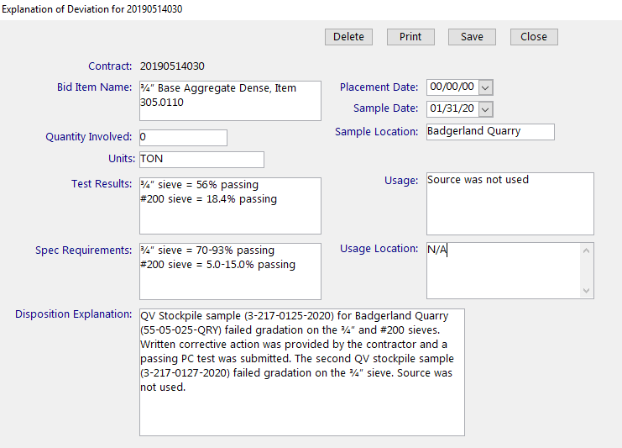
Figure: MIT Entry Aggregate Stockpile Failure Example

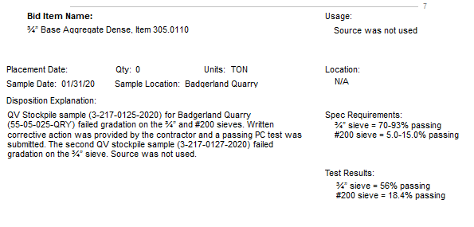
Figure: Printed DT1310 Aggregate Stockpile Failure Example

